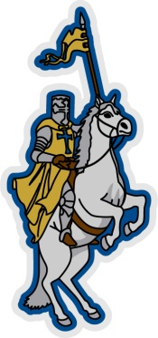
O B C A
2013-2014 School Calendar

August 12-13, 2013 Staff Development
August 14, 2013 Students First Day
September 2, 2013 Labor Day
November 25-29, 2013 Thanksgiving Holiday
December 23, 2013 – January 3, 2014 Christmas Holiday
January 20, 2014 MLK Holiday
February 17, 2014 President’s Day
March 3-7, 2014 Spring Break
April 18-25, 2014 Easter Holiday
May 22, 2014 Students Last Day
May 23, 2014 Staff Development

