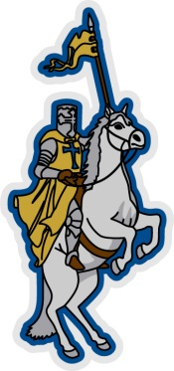
O B C A
2014-2015 School Calendar

August 11-12, 2014 Staff Development
August 13, 2014 Students First Day
September 8, 2014 Labor Day
September 12, 2014 Mid Quarter
October 15, 2014 1st Quarter Ends
November 14, 2014 Mid Quarter
November 24-28, 2014 Thanksgiving Holiday
December 22 – January 2, 2015 Christmas Holiday
January 7, 2015 2nd Quarter Ends
January 19, 2015 MLK Holiday
February 6, 2015 Mid Quarter
February 16 - 20, 2015 Spring Break
March 11, 2015 3rd Quarter Ends
March 30 – April 3, 2015 Easter Holiday
April 17, 2015 Mid Quarter
May 21, 2015 Quarter Ends/Students Last Day
May 22, 2015 Staff Development

