**NEWS**

It has been an **exciting** first nine weeks of school:

* The gift of **salvation accepted**! *Psalm 32:1 Blessed is he whose transgression is forgiven, whose sin is covered.*
* Bro Mel has added **music** to our chapel time. What a blessing to hear these young voices sing unto the Lord!
* **Creativity** abounds…scarecrows, pumpkins, 4-H campaign posters, science posters, posters about student’s favorite pet
* **Fittings** for letter jackets, design of class rings, and **selection** of graduation announcements!
* 11th & 12th grade students began their venture into **college** **courses** via dual enrollment classes for English and Spanish II.

**1 Peter 3:8 To sum up, all of you be harmonious, sympathetic, brotherly, kindhearted, and humble in spirit**

**October 2014**

**Old Bethel Christian Academy Newsletter**

**www.obca.info**

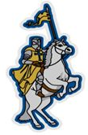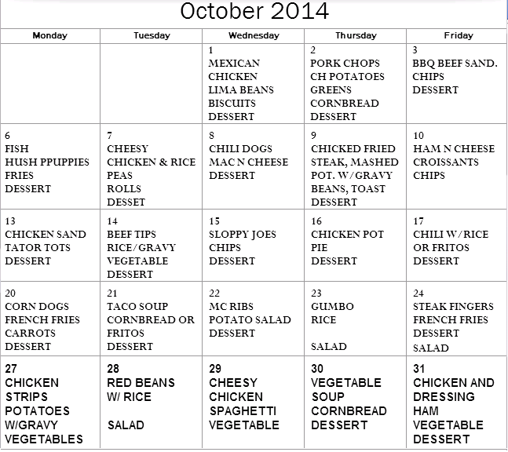

**Events**

* **Chapel**

**6th-11th Wednesday’s at 8am**

**PreK-5th Thursdays at 8am**

* **Oct 7, Thu** @ 6:30p **–**

School Board Meeting

* **Oct 11, Sat - Art Festival Booth**

**Home baked goodies…YUM!**

* **Oct 13, Mon –** PreK to 2nd Grade trip to Pumpkin Patch at First Methodist Church
* **Southern Heritage order forms will be sent home Oct 13. Due Oct 31.**
* **Nov 7, Fri – OBCA Homecoming**
* **Nov 15, Sat – Annual Fall Festival and Gumbo Cook-off**



**Don’t Forget We need your help**

**Art Festival Booth** - providing baked goods to sell and/or working the booth. Please have baked goods at the school by 3pm Friday, October 10th. If you can help work the booth, you can call the school office (649-0281) to schedule a time.

**Annual Fall Festival** – Gumbo Cook-off; Cake Walk, Games, Live and Silent Auction. Stay tuned for more information!

**DON’T FORGET to turn in:**

**Boxtops**: **Community Coffee**:

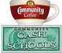

**Coca-Cola Rewards**:



Other ways to support OBCA:

Target RedCard

Office Depot Choice Member